1)
First Order Equations:

Logistic Map:
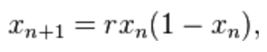
Towers of Hanoi: A game consists of disks and stacks. You can only move one disk at a time and only move it if it is top of the stack
Hn=2Hn−1+1

Compound Interest: Compunding can be found by adding interest to the principal sum of a loan or a deposit. Compound interest is the interest of this interest.
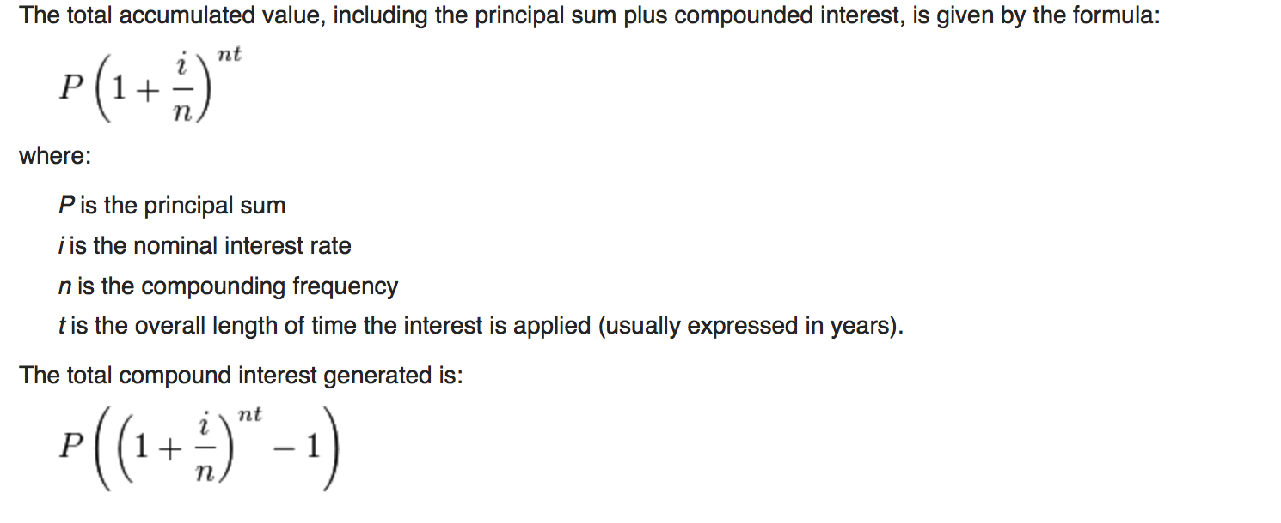

Second Order Equations:
Padovan Sequence: The sequence is defined by the following reccurrence relation

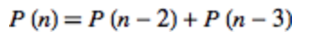
where,

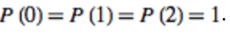
Solution:
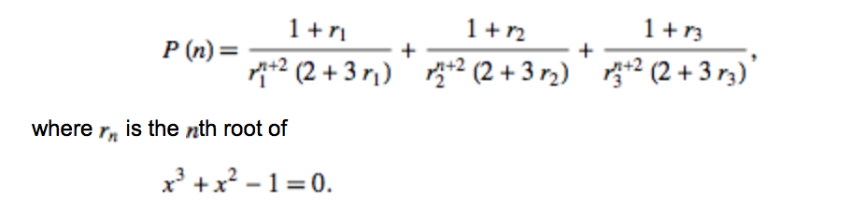

Perrin Sequence:
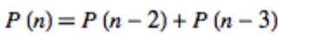
where,
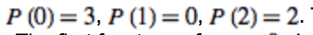
This equation is same as the padovan sequnce but the initial conditions differ.

Fibonacci Number: Used for the calculatio of the golden ratio and rabbit populations.
Where F₀=0 F₁=1

Q1)
i) X_{n}=(97/100)*x_{n-1}+65+360
x₀ = 5000
x₁= (97/100)*x₀+65+180

ii)
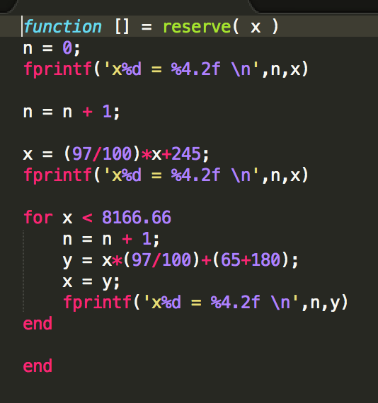
i
ii)Stable

Q2)
i)X_{n}=x_{n-1}*(109/100)+k*1000+(k-1)*2500
x₀ = 40000
k = 1 if n % 2 = 1
k = 0 if n % 2 = 0

ii)
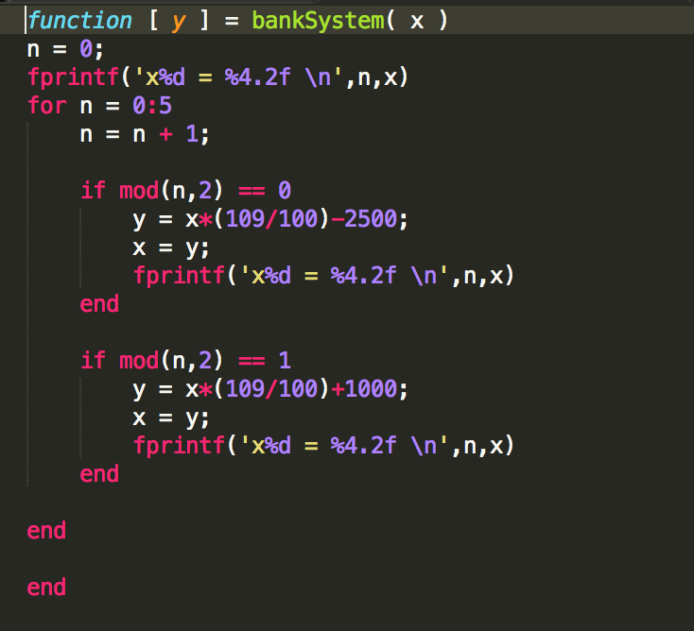

iii) Not Stable.

